US Precious Metal Miners
Quarterly Growth Research: Operating Cash Flow & Sequential Turnover
63-Stock Universe (ShareScope) | Latest reported quarter vs prior quarter | Consolidated 01 June 2026 (London)

Introduction
This consolidated report brings together growth, performance and valuation screens across the 63-stock US Precious Metal Miners universe. Table 1 ranks the top 10 by latest-quarter operating cash flow growth (from the ShareScope data sheet). Table 2 ranks the top 10 by sequential quarter-on-quarter turnover (revenue) growth, combining figures derived from SEC XBRL filing data with figures gathered company-by-company from quarterly filings and investor-relations releases for the many foreign filers that do not tag quarterly turnover in EDGAR. Table 3 lists the full set of 23 companies for which a reliable sequential turnover figure could be established. Tables 4 and 5 then overlay share-price performance and valuation metrics onto that ranking, and three quadrant charts visualise the key relationships. A cross-reference, overlay interpretation and summary follow.
Method note: sequential turnover compares each company's latest reported quarter with the immediately preceding quarter. For calendar-year filers this is Q1 2026 versus Q4 2025; a few companies have offset fiscal calendars (noted in Table 3). Year-to-date figures were de-cumulated into discrete quarters where necessary. Valuation metrics (price, MCAP, PSR, PE, P/NTAV) are from the ShareScope sheet and are 20-minute delayed, in US$.

Table 1 - Top 10 by Latest-Quarter Operating Cash Flow Growth
Ranked on the ShareScope field 'Latest Q Op. cash flow %chg'. Net Debt/MCAP: negative denotes net cash. P/NTAV used as a proxy for price-to-tangible-book.
# | Company | Ticker | Latest-Q OCF %chg | Price ($) | MCAP ($m) | PSR (TTM) | PE (TTM) | P/NTAV | Net Debt / MCAP
1 | Avino Silver & Gold | ASM | +1,698.3% | 7.34 | 1,289 | 11.3 | 104.9 | 4.5 | -10.1%
2 | Vox Royalty | VOXR | +1,364.2% | 5.84 | 401 | 13.9 | 13.0 | 3.0 | -4.0%
3 | IAMGold | IAG | +568.6% | 17.89 | 10,353 | 3.1 | 9.9 | 2.4 | +1.0%
4 | Endeavour Silver | EXK | +508.8% | 9.96 | 2,950 | 5.3 | 498.3 | 4.6 | +0.5%
5 | Hecla Mining | HL | +443.5% | 17.78 | 11,919 | 7.4 | 24.8 | 4.6 | -2.7%
6 | Equinox Gold | EQX | +418.3% | 13.57 | 10,729 | 4.6 | 21.2 | 1.7 | +2.3%
7 | Coeur Mining | CDE | +403.9% | 19.32 | 19,905 | 5.3 | 17.9 | 2.0 | -0.4%
8 | First Majestic Silver | AG | +297.5% | 21.09 | 10,439 | 7.1 | 81.1 | 3.6 | -6.4%
9 | Idaho Strategic Resources | IDR | +264.0% | 39.16 | 617 | 12.6 | 27.4 | 5.3 | -3.0%
10 | Aris Mining | ARIS | +256.5% | 18.13 | 3,746 | 3.3 | 16.2 | 2.4 | +2.4%
Note: a cash-flow screen, not a revenue screen. The largest percentage jumps (Avino, Vox Royalty) come off small absolute bases, which flatters the headline figure.

Table 2 - Top 10 by Sequential Quarterly Turnover Growth (Combined Sources)
Latest reported quarter versus the immediately preceding quarter. Shaded rows also appear in the Operating Cash Flow Top 10 (Table 1). 'Source' indicates whether the figure came from SEC XBRL data or directly from a company filing / investor-relations release.
# | Company | Ticker | QoQ Turnover % | Latest Q | Prev Q | Price ($) | MCAP ($m) | PSR | PE (TTM) | P/NTAV | In OCF Top 10 | Source
1 | i-80 Gold | IAUX | +146.1% | Q1 2026 | Q4 2025 | 1.62 | 1,408.20 | 10.2 | 81.2 | 4.6 | No | SEC XBRL
2 | Silvercorp Metals | SVM | +51.4% | Q Dec 2025 | Q Sep 2025 | 12.68 | 2,808.20 | 6.3 | 36.6 | 3.2 | No | Filing
3 | Avino Silver & Gold | ASM | +45.2% | Q4 2025 | Q3 2025 | 7.34 | 1,289.10 | 11.3 | 104.9 | 4.5 | Yes | SEC XBRL
4 | Coeur Mining | CDE | +26.8% | Q1 2026 | Q4 2025 | 19.32 | 19,904.80 | 5.3 | 17.9 | 2 | Yes | Filing
5 | Royal Gold | RGLD | +25.0% | Q1 2026 | Q4 2025 | 224.48 | 19,050.90 | 14.6 | 26.3 | 2.6 | No | Filing/SEC
6 | Triple Flag | TFPM | +23.6% | Q1 2026 | Q4 2025 | 31.88 | 6,591.40 | 14.6 | 31.6 | 3.1 | No | Filing
7 | Endeavour Silver | EXK | +21.5% | Q1 2026 | Q4 2025 | 9.96 | 2,950.30 | 5.3 | 498.3 | 4.6 | Yes | Filing
8 | Kinross Gold | KGC | +19.0% | Q1 2026 | Q4 2025 | 30.20 | 36,033.60 | 4.6 | 13.4 | 4 | No | Filing
9 | Agnico Eagle | AEM | +15.2% | Q1 2026 | Q4 2025 | 183.18 | 91,643.70 | 6.8 | 18 | 4.1 | No | Filing
10 | McEwen Mining | MUX | +14.6% | Q1 2026 | Q4 2025 | 21.91 | 1,307.70 | 6.7 | 19.5 | 2 | No | SEC XBRL
Note on Coeur Mining: Q1 2026 revenue ($856m) includes 11 days of New Gold following completion of that acquisition on 20 March 2026, so its sequential figure is modestly flattered. New Gold itself is excluded from all tables, having ceased to be a standalone reporting entity on that date.

Cross-Reference: Companies in Both Top Tens
On the re-ranked, fully-sourced turnover table, 3 companies appear in both the turnover Top 10 and the operating cash flow Top 10 - strength on both measures:
- Avino Silver & Gold (ASM) - turnover +45.2%, and a member of the OCF Top 10.
- Coeur Mining (CDE) - turnover +26.8%, and a member of the OCF Top 10.
- Endeavour Silver (EXK) - turnover +21.5%, and a member of the OCF Top 10.
As before, several OCF Top 10 names (Vox Royalty, IAMGold, Hecla, Equinox, First Majestic) do not appear in the turnover Top 10. In every case this reflects either a more modest sequential turnover figure now that real revenue data has been gathered, or a corporate event (Equinox's Brazil disposal) that makes a clean sequential comparison impossible - not an absence of growth.

Table 3 - Full Sequential Turnover Ranking (All 23 Companies with Reliable Data)
The complete ranked set. Shaded rows are members of the Operating Cash Flow Top 10.
# | Company | Ticker | QoQ Turnover % | Latest Q vs Prev Q | Source | Note
1 | i-80 Gold | IAUX | +146.1% | Q1 2026 vs Q4 2025 | SEC XBRL | -
2 | Silvercorp Metals | SVM | +51.4% | Q Dec 2025 vs Q Sep 2025 | Filing | Mar fiscal year-end
3 | Avino Silver & Gold | ASM | +45.2% | Q4 2025 vs Q3 2025 | SEC XBRL | -
4 | Coeur Mining | CDE | +26.8% | Q1 2026 vs Q4 2025 | Filing | Q1 incl 11 days New Gold
5 | Royal Gold | RGLD | +25.0% | Q1 2026 vs Q4 2025 | Filing/SEC | -
6 | Triple Flag | TFPM | +23.6% | Q1 2026 vs Q4 2025 | Filing | -
7 | Endeavour Silver | EXK | +21.5% | Q1 2026 vs Q4 2025 | Filing | -
8 | Kinross Gold | KGC | +19.0% | Q1 2026 vs Q4 2025 | Filing | -
9 | Agnico Eagle | AEM | +15.2% | Q1 2026 vs Q4 2025 | Filing | revenue line approx; ~+13.6-15.2% band
10 | McEwen Mining | MUX | +14.6% | Q1 2026 vs Q4 2025 | SEC XBRL | -
11 | OR Royalties (Osisko) | OR | +13.6% | Q1 2026 vs Q4 2025 | Filing | -
12 | Hecla Mining | HL | +13.0% | Q1 2026 vs Q4 2025 | Filing | Q4 approx from +13% stmt
13 | Franco-Nevada | FNV | +8.9% | Q1 2026 vs Q4 2025 | Filing | -
14 | Newmont | NEM | +7.2% | Q1 2026 vs Q4 2025 | SEC XBRL | -
15 | TRX Gold | TRX | +6.9% | Q Nov 2025 vs Q Aug 2025 | SEC XBRL | Aug-Nov fiscal qtrs
16 | Wheaton Precious Metals | WPM | +4.2% | Q1 2026 vs Q4 2025 | Filing | -
17 | Alamos Gold | AGI | +3.7% | Q1 2026 vs Q4 2025 | Filing | -
18 | First Majestic Silver | AG | +2.8% | Q1 2026 vs Q4 2025 | Filing | -
19 | Pan American Silver | PAAS | -2.2% | Q1 2026 vs Q4 2025 | Filing | Q4 was a record
20 | IAMGold | IAG | -5.3% | Q1 2026 vs Q4 2025 | Filing | consolidated rev
21 | Eldorado Gold | EGO | -7.8% | Q1 2026 vs Q4 2025 | Filing | -
22 | Barrick Mining | B | -13.0% | Q1 2026 vs Q4 2025 | Filing | lower sales volumes
23 | Gold Resource Corp | GORO | -14.3% | Q1 2026 vs Q4 2025 | SEC XBRL | -

Coverage and Data Quality
Of the 63 companies in the universe, a reliable sequential turnover figure was established for 23. The shortfall is structural, not an oversight:
- A large group are foreign filers (40-F / 6-K) that do not tag quarterly turnover in SEC XBRL; these were gathered by hand from company filings and IR pages, which is why the dataset is now far broader than an EDGAR-only screen could achieve.
- A significant number are pre-revenue explorers and developers (for example Seabridge, NovaGold, Perpetua, Platinum Group Metals, New Found Gold, International Tower Hill, Paramount Gold) with no turnover to compare.
- A few could not be placed on a clean sequential basis due to corporate events: SSR Mining (Copler classified as discontinued operations after a $1.5bn sale) and Equinox Gold (Brazil operations sold and reclassified as discontinued).
- New Gold was acquired by Coeur Mining on 20 March 2026 and is no longer a standalone entity, so it carries no Q1 2026 figure of its own.
- A small number of figures remain provisional pending the exact prior-quarter revenue line (for example Fortuna's Q4 2025 sales, B2Gold's Q4 2025); these are excluded from the ranking rather than estimated. Agnico Eagle's figure sits in a narrow band (~+13.6% to +15.2%) depending on which revenue line is used.

Price-Performance & Valuation Overlay
This overlay layers share-price performance and valuation onto the turnover ranking, to test whether the strongest turnover growers are also showing price momentum and whether they still look reasonably valued. All figures are from the ShareScope sheet (20-minute delayed). Performance is shown over three windows: the last five trading days, year-to-date (since 31 December 2025), and the full 2025 calendar year. Shaded rows are Operating Cash Flow Top 10 members. Companies remain in the turnover-ranking order from Table 3.

Table 4 - Price Performance (turnover-ranked order)
Green denotes a positive move, red a negative move. FY2025 % captures the scale of last year's sector re-rating; YTD and 5-day show momentum into the current period.
# | Company | Ticker | QoQ Turnover % | Price ($) | 5-Day % | YTD % (since 31/12/25) | FY2025 %
1 | i-80 Gold | IAUX | +146.1% | 1.62 | +8.7% | +10.5% | +202.0%
2 | Silvercorp Metals | SVM | +51.4% | 12.68 | +3.7% | +51.8% | +178.0%
3 | Avino Silver & Gold | ASM | +45.2% | 7.34 | +10.5% | +18.4% | +609.0%
4 | Coeur Mining | CDE | +26.8% | 19.32 | +8.4% | +8.4% | +212.0%
5 | Royal Gold | RGLD | +25.0% | 224.48 | +1.0% | +1.0% | +68.6%
6 | Triple Flag | TFPM | +23.6% | 31.88 | -0.0% | -4.0% | +121.0%
7 | Endeavour Silver | EXK | +21.5% | 9.96 | +6.9% | +6.0% | +158.0%
8 | Kinross Gold | KGC | +19.0% | 30.20 | +5.3% | +7.3% | +203.0%
9 | Agnico Eagle | AEM | +15.2% | 183.18 | +3.1% | +8.1% | +117.0%
10 | McEwen Mining | MUX | +14.6% | 21.91 | +2.7% | +18.3% | +138.0%
11 | OR Royalties (Osisko) | OR | +13.6% | 37.04 | +4.2% | +4.6% | +95.5%
12 | Hecla Mining | HL | +13.0% | 17.78 | +2.7% | -7.3% | +291.0%
13 | Franco-Nevada | FNV | +8.9% | 230.89 | +2.3% | +11.4% | +76.2%
14 | Newmont | NEM | +7.2% | 109.85 | +1.4% | +10.0% | +168.0%
15 | TRX Gold | TRX | +6.9% | 1.15 | +4.1% | +25.0% | +203.0%
16 | Wheaton Precious Metals | WPM | +4.2% | 132.72 | +4.3% | +13.0% | +109.0%
17 | Alamos Gold | AGI | +3.7% | 40.86 | +4.1% | +5.9% | +109.0%
18 | First Majestic Silver | AG | +2.8% | 21.09 | +6.2% | +26.6% | +203.0%
19 | Pan American Silver | PAAS | -2.2% | 57.02 | +4.0% | +10.1% | +156.0%
20 | IAMGold | IAG | -5.3% | 17.89 | +6.7% | +8.5% | +219.0%
21 | Eldorado Gold | EGO | -7.8% | 33.84 | +6.8% | -5.8% | +142.0%
22 | Barrick Mining | B | -13.0% | 42.58 | +3.2% | -2.2% | +181.0%
23 | Gold Resource Corp | GORO | -14.3% | 1.38 | +8.3% | +66.4% | +257.0%

Table 5 - Valuation Metrics (turnover-ranked order)
PSR = price/sales (TTM); PE (TTM) and PE (fc) = trailing and forecast price/earnings; PEG = PE-to-growth; Price/FCF = price to free cash flow (negative where trailing FCF was negative); ROCE = return on capital employed; CROCI = cash return on capital invested; P/NTAV = price to net tangible asset value; Net Debt/MCAP negative denotes a net cash position.
# | Company | Ticker | QoQ Turnover % | PSR | PE (TTM) | PE (fc) | PEG | Price/FCF | ROCE % | CROCI % | P/NTAV | Net Debt/MCAP %
1 | i-80 Gold | IAUX | +146.1% | 10.2 | 81.2 | - | - | -11.5 | -15.6 | -14.8 | 4.6 | -5.4
2 | Silvercorp Metals | SVM | +51.4% | 6.3 | 36.6 | 11.2 | 0.2 | 16 | 19.8 | 15.1 | 3.2 | -10.8
3 | Avino Silver & Gold | ASM | +45.2% | 11.3 | 104.9 | 11.1 | 0.1 | - | 19.2 | 0 | 4.5 | -10.1
4 | Coeur Mining | CDE | +26.8% | 5.3 | 17.9 | 10.2 | 0.2 | 17.8 | 24.6 | 21 | 2 | -0.4
5 | Royal Gold | RGLD | +25.0% | 14.6 | 26.3 | 19.3 | 0.5 | -34 | 10.7 | -7.2 | 2.6 | 1.9
6 | Triple Flag | TFPM | +23.6% | 14.6 | 31.6 | 21.1 | 0.6 | 71.4 | 11.4 | 4.9 | 3.1 | -2.2
7 | Endeavour Silver | EXK | +21.5% | 5.3 | 498.3 | 7.8 | 0.08 | -24.6 | 4.8 | -12.6 | 4.6 | 0.5
8 | Kinross Gold | KGC | +19.0% | 4.6 | 13.4 | 9.5 | 0.2 | 14.7 | 31.2 | 24.4 | 4 | -4
9 | Agnico Eagle | AEM | +15.2% | 6.8 | 18 | 13.5 | 0.3 | 21.6 | 20.9 | 14.1 | 4.1 | -3
10 | McEwen Mining | MUX | +14.6% | 6.7 | 19.5 | 13.2 | 0.2 | -40.4 | -3.4 | -5.2 | 2 | 5.5
11 | OR Royalties (Osisko) | OR | +13.6% | 21.5 | 42.1 | 24.3 | 0.6 | 33.6 | 13.3 | 14.4 | 5 | -1.3
12 | Hecla Mining | HL | +13.0% | 7.4 | 24.8 | 20.5 | 0.5 | 37.6 | 17.4 | 10.1 | 4.6 | -2.7
13 | Franco-Nevada | FNV | +8.9% | 21.2 | 51.2 | 24.8 | 0.6 | -63.4 | 18.4 | -9.8 | 5.5 | -1.6
14 | Newmont | NEM | +7.2% | 4.8 | 12.9 | 10.5 | 0.3 | 16.7 | 22.1 | 14.4 | 3.7 | -2.1
15 | TRX Gold | TRX | +6.9% | 3.7 | - | 41.8 | - | 131.7 | 16.4 | 3 | 4.4 | -5.6
16 | Wheaton Precious Metals | WPM | +4.2% | 22 | 53.8 | 24.6 | 0.6 | 100.6 | 19.7 | 6.9 | 6.5 | -3.5
17 | Alamos Gold | AGI | +3.7% | 8.4 | 21 | 14.3 | 0.3 | 61 | 16.6 | 5 | 3.7 | -2.6
18 | First Majestic Silver | AG | +2.8% | 7.1 | 81.1 | 14.6 | 0.2 | 33.8 | 11.8 | 10.2 | 3.6 | -6.4
19 | Pan American Silver | PAAS | -2.2% | 6 | - | 12.3 | 0.3 | 20.6 | 15.6 | 13.7 | 3.3 | -2.7
20 | IAMGold | IAG | -5.3% | 3.1 | 9.9 | 7.3 | 0.1 | 13.3 | 21.8 | 16.5 | 2.4 | 1
21 | Eldorado Gold | EGO | -7.8% | 3.4 | 12.5 | 7.9 | 0.1 | -43.9 | 13.7 | -3 | 1.6 | 7
22 | Barrick Mining | B | -13.0% | 3.7 | 12.5 | 10.4 | 0.3 | 18.1 | 18.6 | 8.8 | 3 | -3.4
23 | Gold Resource Corp | GORO | -14.3% | 1.7 | 20.2 | 27.5 | - | 293.2 | 11.3 | 0.4 | 4.6 | -13

Overlay Interpretation
Turnover growth has not translated into share-price outperformance this year. Across the 23 names, the correlation between sequential turnover growth and year-to-date price performance is essentially zero (Pearson r of about 0.02). In other words, knowing which companies grew revenue fastest last quarter told you almost nothing about which share prices rose most in 2026 to date. Several of the weakest turnover names have been among the strongest performers: Gold Resource Corp sits bottom of the turnover table (-14.3%) yet leads year-to-date on price (+66.4%), and First Majestic (+2.8% turnover) is up +26.6%, while Triple Flag (+23.6% turnover) is actually down -4.0% and Hecla (+13.0% turnover) is down -7.3%.
Two readings of that divergence are worth holding side by side. The benign one is that the market re-rated the whole sector hard during 2025 (note the FY2025 column: Avino +609%, Hecla +291%, Gold Resource +257%), so 2026 share prices are digesting last year's move rather than tracking the latest quarter's revenue. The more cautious one is that price momentum in this sector is being driven by the gold and silver price and by individual catalysts (deal news, production milestones) far more than by reported quarterly turnover - so a turnover screen, while useful for spotting operational momentum, is a weak standalone timing signal.
On valuation, the dual-metric names still look the most defensible. Among the top-10 turnover growers, the lowest trailing PEs are Kinross (about 13), Coeur (about 18) and Agnico (about 18), each pairing revenue growth with mid-teens-or-better ROCE. The royalty names (Royal Gold, Triple Flag, and Franco-Nevada and Wheaton lower down) carry the highest price-to-sales ratios (14-22x), which is normal for the capital-light streaming model but leaves less margin for disappointment. The richest earnings multiples sit on the silver developers still ramping - Endeavour (TTM PE distorted by ramp-up costs) and Avino (about 105) - where forecast PEs (Endeavour about 8, Avino about 11) tell a very different story to trailing ones, so the forward column matters more than the trailing for those two.
PEG ratios are low across almost the entire list (many at 0.1-0.3), which simply reflects that forecast earnings growth is large relative to current multiples in a rising metal-price environment - a sector-wide tailwind rather than a stock-specific signal, and one that would reverse quickly if metal prices fell. Net debt is not a concern for most: the majority of the table is in a net cash position (negative Net Debt/MCAP), with only a handful (IAMGold, McEwen, Eldorado, Gold Resource on the metric shown) carrying modest net debt.

Visualising the Overlay
The three quadrant charts below plot the 23 ranked companies (i-80 Gold omitted from charts 1 and 3, as its +146% off a tiny base would compress the scale). Diamonds mark Operating Cash Flow Top 10 members.
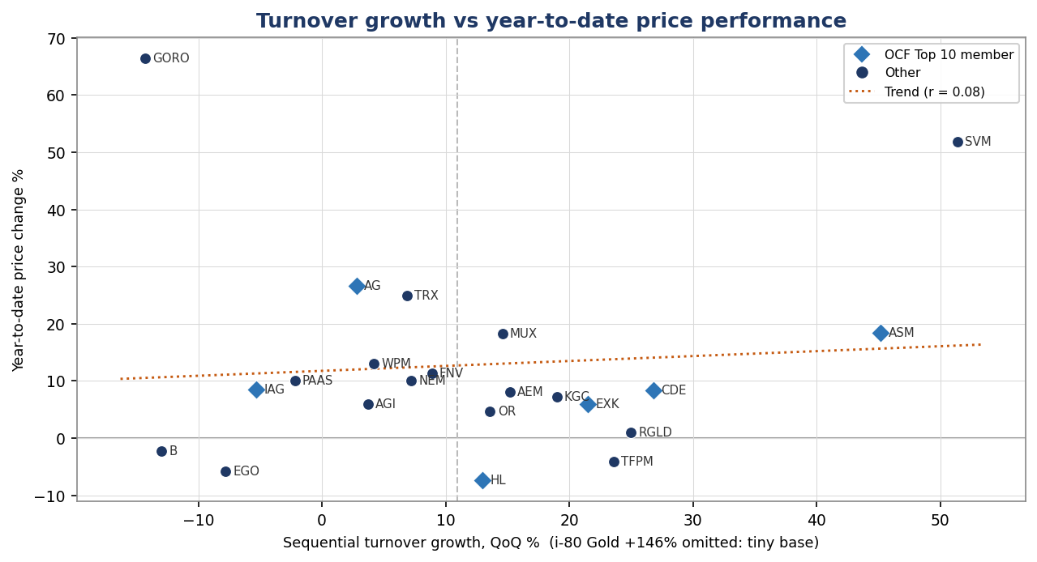
Chart 1: turnover growth (horizontal) against year-to-date price change (vertical). The dotted trend line is almost flat (r = 0.08 on the plotted set, ~0.02 across all 23), confirming that the quarter's revenue growth has had little bearing on this year's share-price moves. Note Gold Resource Corp (GORO) top-left - the weakest turnover yet the strongest price - and Triple Flag (TFPM) and Hecla (HL) below the zero line despite solid turnover growth.
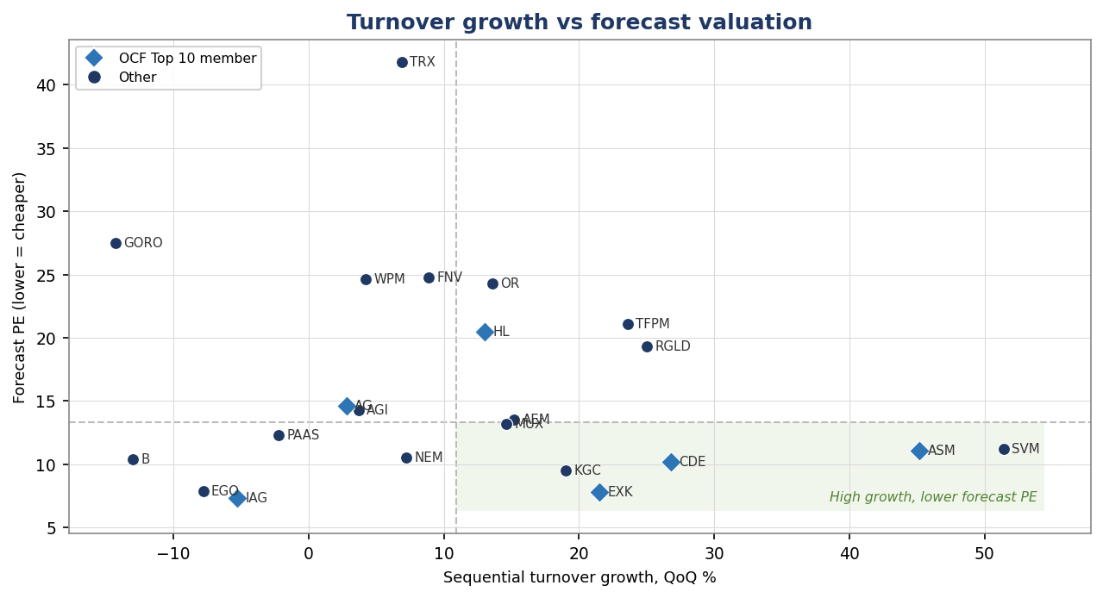
Chart 2: turnover growth (horizontal) against forecast PE (vertical, lower = cheaper). The shaded lower-right quadrant - above-median growth at below-median forecast PE - is the growth-at-a-reasonable-price sweet spot. It is populated by exactly the dual-metric names highlighted elsewhere in this report: Coeur (CDE), Endeavour Silver (EXK), Kinross (KGC), Avino (ASM) and Silvercorp (SVM), with several of these also being OCF Top 10 members (diamonds).
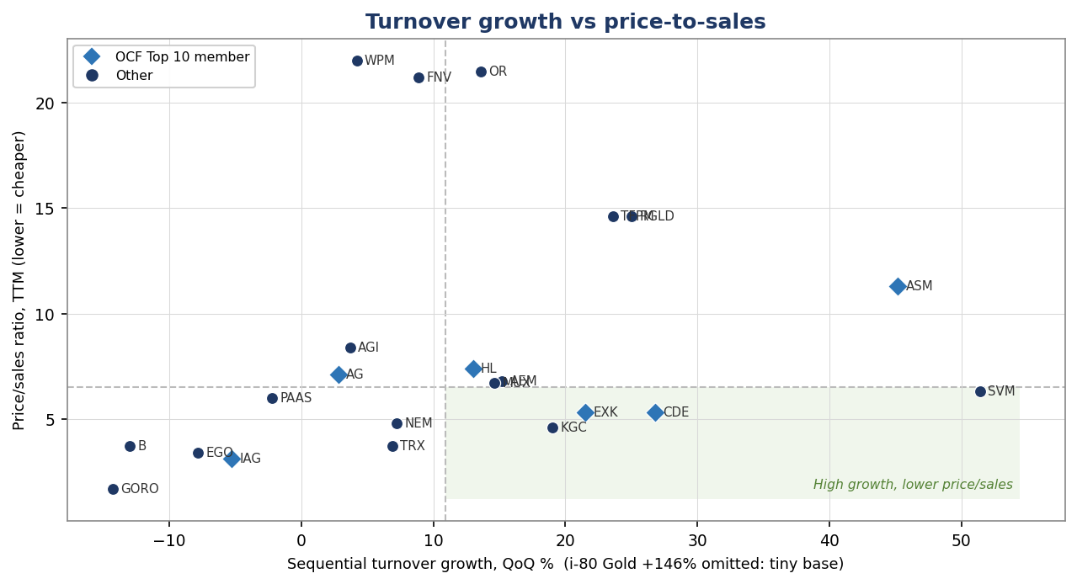
Chart 3: turnover growth (horizontal) against price-to-sales (vertical, lower = cheaper). Price/sales is a natural pairing in a revenue-driven sector, and it isolates the royalty-and-streaming premium clearly: Wheaton (WPM), Franco-Nevada (FNV) and OR Royalties (OR) sit at the top on 21-22x sales, with Royal Gold (RGLD) and Triple Flag (TFPM) next at around 14-15x - the structural price of the capital-light model rather than a sign of expensiveness. The producers sit far lower. The shaded high-growth, lower-price/sales quadrant again captures Coeur, Endeavour, Kinross and Silvercorp, while Avino (ASM) is the notable exception - strong growth but a producer-level PSR above 11, a reminder that its headline multiples sit well above its peers.

Overall Summary
With real revenue data assembled across the producers and royalty companies, the strongest sequential turnover growth is concentrated in the silver-leaning names and a handful of smaller producers ramping new output. i-80 Gold tops the list (+146%) but off a very small base with a widening loss, so the percentage flatters it. Silvercorp (+51%, on its offset fiscal calendar) and Avino (+45%) follow. Among names combining genuine scale with dual-metric strength, Coeur Mining (+27% turnover, and an OCF Top 10 member) and Endeavour Silver (+22%, also OCF Top 10) stand out, alongside the royalty pair Royal Gold (+25%) and Triple Flag (+24%). The gold majors were more mixed: Kinross (+19%) and Agnico (~+15%) grew, while Barrick (-13%) and IAMGold (-5%) saw sequential revenue dip on lower sales volumes despite higher metal prices. Layering on price and valuation, the key caveat is that turnover momentum has not led share prices this year (near-zero correlation with year-to-date returns), so the turnover ranking is best read as a measure of operational momentum and a candidate-generation tool, not a price-timing signal. On valuation, the names that screen well on both turnover and cash flow - notably Coeur, Kinross and Agnico - also carry the more reasonable trailing earnings multiples, making them the most internally consistent on this combined view.

Risk Warning
Investing involves significant risks, including potential loss of your entire investment. Values fluctuate and past performance does not guarantee future results. This analysis is not financial advice. Assess your financial situation, risk tolerance, and investment objectives carefully. Conduct your own research (DYOR) and consult an independent financial adviser before making decisions.
DYOR: Cedric, Mick's AI Research Assistant (01 June 2026)

